Healthy Path Foundation
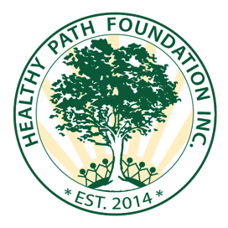
Sponsor Form
The Healthy Path Foundation presents our Fall Festival on Saturday October 14, 2017 from 12:00-5:00 pm at Henry Kaufmann Campgrounds, 1131 Manor Road Staten Island, NY 10314. We will be hosting many activities for families and children including our stations dedicated to Top Ten Healthy Habits (please see our website at www.HealthyPathFoundation.org for the full list)

Opportunities to sponsor include:
Tier 1 Level $100- sponsor will be listed on website
Tier 2 Level $200- sponsor will be on website and T Shirt
Tier 3 Level $300- sponsor will be on website, T Shirt, and have table space
at event with company banner provided
Event sponsor opportunities:
Bouncy Castles
Art supplies for Pumpkin decorations
Raffle prizes for Healthy Habits
T Shirts
DJ
Healthy snack/drinks
Contact us for more information

Deadline to sponsor is September 30, 2017
Please indicate which level of sponsorship
Name: ______________________________________________________
Company Name: ______________________________________________
Address: _____________________________________________________
Phone: ______________________________________________________
Email: _______________________________________________________
Please make checks payable to:
The Healthy Path Foundation, 50 91st Street, Brooklyn NY 11209
Email us at info@healthypathfoundation.org for more information
The Healthy Path Foundation has its 501(c)3 non-profit status with the Tax Id# 47-1561927

